Day 7

1. Login Functionality

* First we made a blade template, then added routes and controllers





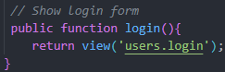

* Then for the authentication too





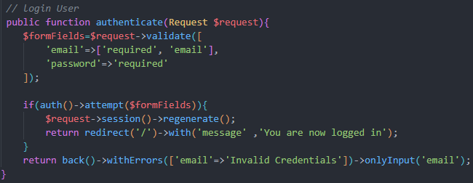

1. Auth and Guest middleware (because right now even guests can delete and update the posts)

* We don’t want the guest to post so we do this





This uses in built authentication middleware and this will pass us to slash login when trying to post as a guest

* We added ->middleware(‘auth’) to every route we don’t want the guest to access. Only the login one needed name
* Now when logged in we can still go to register route. So we need to fix it
* So we did this to register and login routes



But by default this will transfer the route to slash home

To change that, we need to go to providers then route service provider and change

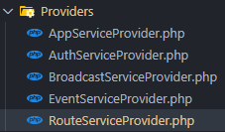

1. Relationships

* First in our migrations we added foreign key



* Then in out listing factory we added this code. THIS WAS CAUSING ERROR EARLIER



* Then in our database seeder we added these code and commented out others

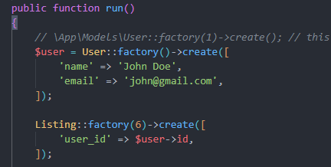

* Then we did



* Now in the database we got all listing with user id as foreign key

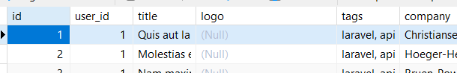

* And got user with that foreign key with id



* Now for proper relationship we can do this in models listing

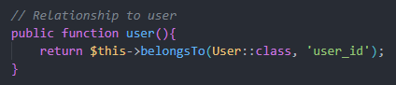

* And in models user

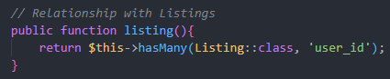IT SHOULD BE LISTINGS

1. Tinker tinkering

* With this command we can open tinker



* We can now see the values by doing this

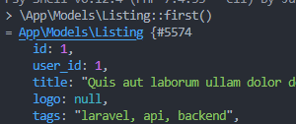

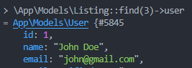

A fun tool to mess around with

1. Add owner ship to the listings



1. Managing Listing Page

* We made the routes



* Then controller

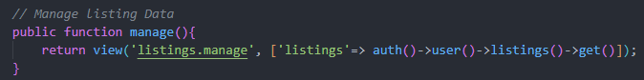

* Then in view

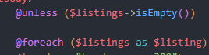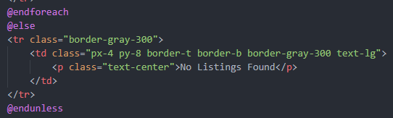

1. User authorization

* This is easy as we have to write 3 lines before the update and delete function

